1. Run dependency walker and Open the TestTrack Client

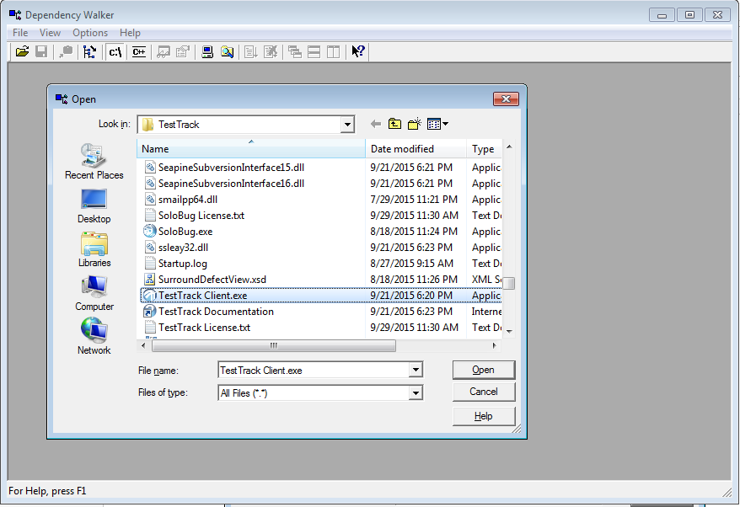

1. Make sure the Full File Paths are turn on

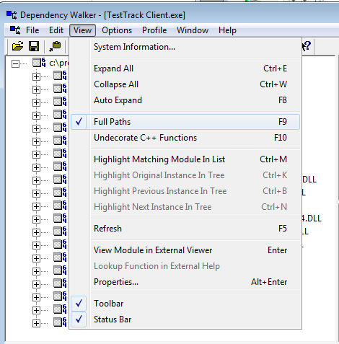

1. Check for the libeay32.dll module and try to show as much of the tree structure as possible for how it was loaded. This is often easiest by looking for it in the flat list and using the “Highlight Matching Module in Tree” right-click option. In my case libeay32.dll is loaded directly by TestTrack Client.exe. Based on the behavior I’m wondering if libeay32.dll is a dependency of some other library and not directly TestTrack Client.exe.

